CASE STUDY ANALYSIS
INTELLIGENT INSURANCE CLAIM MANAGEMENT SYSTEM
Course : Software Engineering
Course Code : CSA1005
Student Name : S.D. Riyaz Kamal
Register Number : 192572049
Dept : CSE (A.I)
Assessment Tool 1 – Case Study Analysis

1. Understand the Problem Statement
1.1 Problem Description
The Intelligent Insurance Claim Management System is a software application designed to simplify and automate the insurance claim process. Insurance companies receive claims for vehicles, property, travel, health, and other insured assets. Claim processing involves collecting documents, verifying information, assessing losses, investigating cases, making approval decisions, and settling payments.
The proposed system provides a centralized digital platform where customers can register policy details, submit claims, upload supporting documents, and monitor progress. Authorized employees can verify documents, assign claims to assessors, record assessment results, manage decisions, and track settlements. The system also generates analytical reports to support operational improvements.
1.2 Objectives of the System
- Register and maintain insurance policy information.
- Enable customers to submit claims digitally.
- Collect and securely store supporting documents.
- Provide claim status tracking.
- Assign claims to assessors and investigators.
- Record assessment and investigation results.
- Manage claim approvals and rejections.
- Track settlement amounts, payment status, and transaction details.
- Generate claim analytics and management reports.
- Reduce paperwork and improve customer communication.
1.3 Scope of the Problem
The system covers the insurance claim lifecycle from digital submission to settlement or rejection. It includes customer and policy management, document collection, verification, assessment, investigation, approval, settlement, notifications, reporting, and workflow configuration. It can support vehicle, property, travel, and health insurance, with configurable requirements for each category.
The system supports decision-making but does not guarantee automatic fraud detection or approval of every valid claim. Final decisions must follow policy conditions, company procedures, and applicable regulations.

2. Identify Key Stakeholders and Challenges
2.1 Key Stakeholders and Responsibilities
Stakeholder | Responsibilities | Major Challenges
Customers / Policyholders | Submit claims, provide documents, track status. | Delays, unclear requirements, limited status visibility.
Insurance Agents | Assist customers and explain policy/claim requirements. | Managing many requests and coordinating departments.
Claim Officers | Verify policy details and documents; coordinate decisions. | High claim volume, incomplete records, manual errors.
Assessors | Inspect loss or damage and recommend claim amounts. | Incomplete information, scheduling, accurate reporting.
Investigators | Review suspicious or complex claims and collect evidence. | Reliable evidence collection and progress tracking.
Finance / Settlement Team | Record approved amounts, payment dates, and transaction references. | Payment accuracy, duplicate-payment prevention, pending settlements.
Insurance Management | Monitor performance, costs, claim trends, and customer satisfaction. | Accurate reporting and identifying bottlenecks.

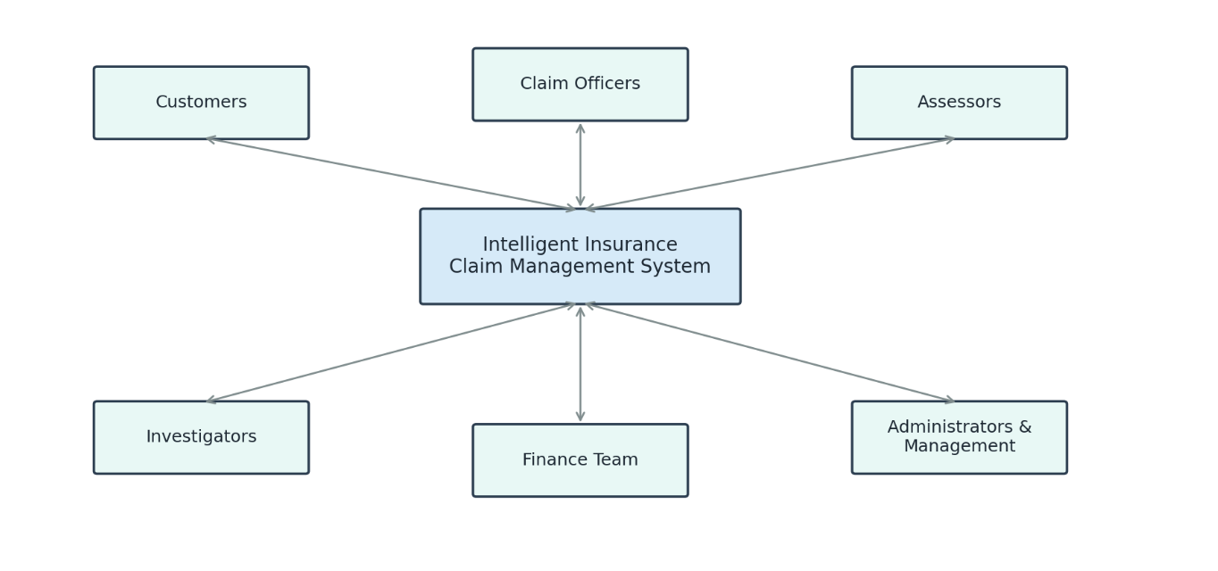
2.2 Major Challenges
- Processing delays caused by manual verification and approvals.
- Missing, duplicated, or misplaced supporting documents.
- Limited transparency about current claim status.
- Data-entry mistakes and inconsistent records.
- False or inconsistent information that may indicate fraud.
- Slow communication between customers and departments.
- Protection of sensitive personal, medical, and financial information.
- Different insurance categories requiring different workflows.

3. Analyse the Current Approach
3.1 Existing System
In a traditional process, customers submit claims through physical forms, email, agents, or separate online services. Employees collect and verify documents, check policy details, and forward claims for assessment or investigation when required. Authorized personnel then approve or reject the claim. Approved claims are sent to the settlement department. Customers may need to contact the insurer to receive progress updates.

3.2 Strengths of the Existing System
- Human employees can use professional judgment for complex cases.
- Established procedures provide a basis for verification and approval.
- Physical inspections can help assess actual damage or loss.
- Manual investigation can accommodate unusual circumstances.
- Clear assignment of responsibilities can support accountability.

3.3 Limitations of the Existing System
- Paperwork and manual processing increase administrative effort.
- Verification and approval can take considerable time.
- Customers may not have clear visibility into claim progress.
- Separate records can become inconsistent or difficult to retrieve.
- Repeated data entry increases the possibility of errors.
- Communication between departments may be slow.
- Management reports require extra effort when data is not centralized.
- Tracking past assessments and settlement decisions can be difficult.

3.4 Gaps to Be Addressed
The current approach may lack a single platform for managing the entire claim lifecycle. The proposed system addresses this gap through centralized policy and claim records, digital document uploads, unique claim numbers, status tracking, assessor assignment, digital decision records, settlement tracking, notifications, and analytical reports.

4. Proposed Solution Using Software Engineering Principles
4.1 Proposed Solution
The system will be a centralized web application for customers and authorized insurance employees. Customers submit claims and documents; the system creates a claim reference number and checks for required information. Claim officers verify the policy and documents, request missing information, and assign claims for assessment or investigation..
Intelligent features may include document completeness checks, duplicate-claim alerts, rule-based routing, and anomaly detection to identify cases needing additional review. These features should support staff rather than make high-impact decisions without appropriate human oversight.
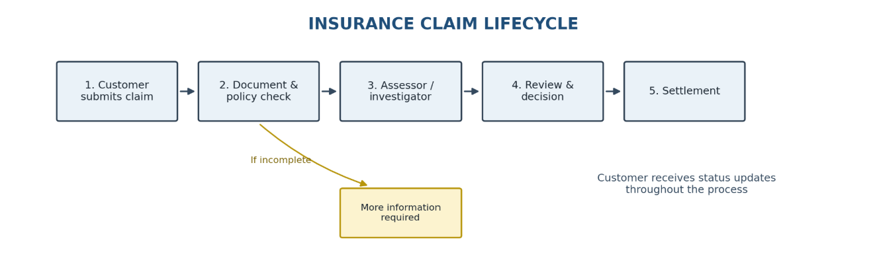

4.2 Major Functional Modules
User Management: Customer registration, login, profile management, authentication, and role-based access.
Policy Management: Policy numbers, coverage, insurance category, validity, and related details.
Claim Submission: Digital claim forms, incident information, claim reference number generation, and submission tracking.
Document Management: Secure uploads, document categorization, retrieval, and missing-document identification.
Claim Verification: Policy checks, document review, and requests for additional information.
Assessment and Investigation: Assignment to assessors/investigators, inspection findings, evidence, notes, and recommendations.
Approval and Rejection: Authorized decisions, decision reasons, timestamps, and responsible user records.
Settlement Management: Approved amount, payment status, payment date, and transaction reference.
Notifications: Updates when claims are submitted, documents are requested, decisions are made, or settlements are processed.
Analytics and Reporting: Claim volumes, pending claims, processing times, decision rates, and settlement trends.
Workflow Configuration: Configurable stages, assignment rules, approval levels, and document requirements.
4.3 Functional Requirements
- The system shall allow customers to register and log in securely.
- The system shall maintain insurance policy information.
- The system shall allow digital claim submission and generate a unique claim ID.
- The system shall generate claim reports and analytics.
- The system shall support configurable workflows and role-based access.

4.4 Non-Functional Requirements
Security: Protect records through secure authentication, permissions, encryption, and secure document storage.
Reliability: Maintain consistent records and protect against accidental data loss.
Performance: Respond promptly and support multiple users.
Scalability: Support growth in users, claims, and document volume.
Usability: Provide clear forms, messages, and navigation.
Maintainability: Use modular code, documentation, version control, and automated tests.
Availability: Use backups, monitoring, and recovery procedures.
Privacy: Restrict personal, medical, and financial information to authorized users.
Interoperability: Support secure integration with payment, notification, and existing insurance systems.
4.5 Application of Software Engineering Principles
Modularity: Separate modules make development, testing, and updates easier.
Scalability: Infrastructure can be expanded as claim volumes increase.
Maintainability: Organized code and documentation simplify changes.
Reliability: Validation, transaction handling, backups, and error handling protect data quality.
Usability: Guided forms and clear status messages improve the user experience.
Security: Authentication, role-based permissions, encryption, and audit logs protect information.
Reusability: Shared functions such as uploads and notifications can serve multiple insurance categories.
Configurability: Workflow rules can be adjusted without redesigning the whole system.
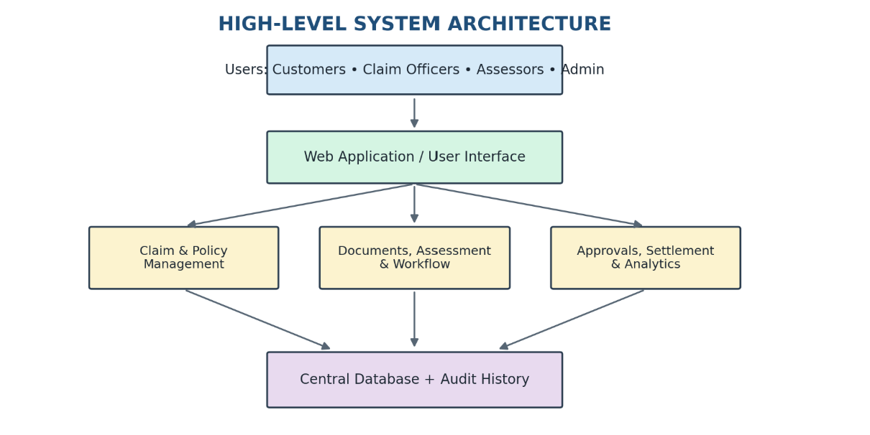

5. Justify the Chosen Methodology / Framework
5.1 Selected Methodology: Agile with Scrum
Agile with Scrum is suitable because the system contains multiple modules and requirements may change after feedback from customers, claim officers, assessors, and management. The project can be divided into short iterations called sprints, with each sprint delivering a tested part of the application.

5.2 Reasons for Selecting Agile
Incremental development: Start with user management, policy records, and claim submission, then add assessment, settlement, and analytics.
Continuous feedback: Stakeholders can review features and request improvements.
Flexibility: Changing workflow rules and documentation requirements can be incorporated into future sprints.
Early testing: Frequent testing helps identify issues before the entire system is complete.
Risk management: Security, data protection, and integration risks can be addressed progressively.
Team collaboration: Developers, testers, analysts, and stakeholders can coordinate throughout development.

5.3 Support for Development and Maintenance
Agile supports development through working software increments, stakeholder feedback, and adaptation to changing requirements. After deployment, user feedback and reported issues can be prioritized in the product backlog. Regular tests, code reviews, documentation, and controlled releases help maintain software quality.

5.4 Proposed Scrum Sprint Plan
Sprint | Deliverables
Sprint 1 | Requirements, user roles, registration, login, and profiles.
Sprint 2 | Policy management, digital claim submission, and claim IDs.
Sprint 3 | Document uploads, completeness checks, and verification.
Sprint 4 | Claim assignment, assessment, and investigation tracking.
Sprint 5 | Approval/rejection workflows and settlement management.
Sprint 6 | Notifications, analytics, security/integration testing, and deployment.

6. Expected Outcomes and Limitations
6.1 Expected Outcomes
Faster processing through digital submission and structured workflows.
Improved transparency through customer status tracking.
Reduced paperwork through electronic forms and document storage.
Better document organization and retrieval.
Improved communication through automated notifications.
Improved accountability through audit history.
Fewer record inconsistencies through validation and centralized data.

6.2 Challenge-to-Solution Mapping
Existing Challenge | Proposed Solution
Slow claim processing | Digital forms and configurable workflows
Missing documents | Document checklists and completeness validation
Poor status visibility | Customer claim-tracking dashboard
Manual data-entry errors | Input validation and centralized records
Difficult claim assignment | Structured assignment module
Delayed communication | Automated notifications
Settlement tracking difficulties | Settlement management module
Limited management reports | Analytics and reporting
Unauthorized access | Authentication and role-based permissions
Incomplete claim histories | Audit logs and centralized records

6.3 Risks and Limitations
Data security risks: A breach could expose confidential information. Mitigation: encryption, access controls, secure backups, and security testing.
Incorrect or fraudulent information: Automated checks cannot detect every false claim. Mitigation: combine validation, alerts, document checks, and human investigation.
Implementation cost: Development and maintenance require resources. Mitigation: deliver essential modules first and expand incrementally.
System downtime: Failures may temporarily interrupt access. Mitigation: monitoring, backups, and recovery procedures.
Poor data quality: Incomplete records can reduce analytics accuracy. Mitigation: establish validation and data-quality reviews.

6.4 Future Enhancements
- AI-assisted document processing to extract relevant information and identify missing fields.
- Anomaly detection to flag unusual claim patterns for investigation.
- A mobile application for claim submission and status updates.
- Advanced workflow configuration for different insurance categories.
- Customer feedback collection after claim completion.
- AI-based features should be tested for accuracy, fairness, privacy, and suitability before being used in real insurance operations.

Conclusion
The Intelligent Insurance Claim Management System provides a centralized solution for managing the insurance claim lifecycle. Customers can submit claims digitally, upload documents, and track progress, while authorized employees can verify information, assign assessments, record investigations, manage decisions, and monitor settlements.
Applying modularity, scalability, maintainability, reliability, usability, and security helps create a system that can be developed and maintained effectively. Agile with Scrum supports incremental development, continuous feedback, and adaptation to changing requirements. Although security, cost, integration, and data quality remain important challenges, the proposed system can reduce paperwork, improve transparency, and increase the efficiency of insurance operations.

